**SVKM’s NMIMS**

**Mukesh Patel School of Technology Management & Engineering**

A.Y. 2023 - 24

**Course: Machine Learning**

**Project Report**

|  |  |  |
| --- | --- | --- |
| Program | MBA TECH AI | |
| Semester | IV | |
| Name of the Project: | ss | |
|  | | |
| Details of Project Members |  |  |
| Batch 1 | Roll No. | Name |
|  | R020 | Kaushal Jain |
|  | R021 | Keshav Kothari |
|  | R022 | Krishna Bansal |
| Date of Submission: 01/04/2024 | | |

**Contribution of each project Members:**

|  |  |  |
| --- | --- | --- |
| Roll No. | Name: | Contribution |
| R020 | Kaushal Jain | contributed in ideation, data collection and preprocessing (1), beautification |
| R021 | Keshav Kothari | Contributed in ideation data preprocessing (2) and features extraction and model fitting, data collection |
| R022 | Krishna Bansal | Contributed in ideation of project model training and testing and error handling, data collection, preprocessing (3) |

**Github link of your project:**

**Note:**

1. Create a readme file if you have multiple files
2. All files must be properly named (I004_MLProject)
3. Submit all relevant files of your work
4. **Plagiarism is highly discouraged (Your report will be checked for plagiarism)**

**Rubrics for the Project evaluation:**

|  |
| --- |
| * Evaluation of project will be based on following rubrics * Domain knowledge and literature review in the selected topic (5 marks) * EDA, Implementation and performance metrics used (10 marks) * Beyond classroom knowledge gained and implemented (5 marks) |

**Project Report**

**INDIAN MUSIC GENRE CLASSIFICATION AND IDENTIFICATION**

**By**

**Kaushal Jain, Roll number: R020**

**Keshav Kothari, Roll number: R021**

**Krishna Bansal,Roll number: R022**

**Course: Machine Learning**

**AY: 2023-24**

**Table of Contents**

|  |  |  |
| --- | --- | --- |
| **Sr no.** | **Topic** | **Page no.** |
| **1** | Storyline or Applications of Project |  |
| **2** | Literature Review |  |
| **3** | Data Preprocessing and Exploratory data Analysis with Visualization |  |
| **4** | Machine learning models with hyper parameter tuning |  |
| **5** | Performance Evaluation |  |
| **6** | Comparison of different techniques used |  |
| **7** | Deployment/GUI/ Learning beyond classroom |  |
| **8** | Learnings and challenges you faced while doing the Project |  |
| **9** | Conclusion |  |

**I.** **Storyline or Applications of Project**

This project addresses the limitations of current music streaming services by developing a software tool called the "Indian Song Genre Identifier." This tool leverages machine learning to classify Indian songs into their respective genres based on audio features. The applications extend beyond personal music libraries, with potential to enhance music streaming recommendations, empower music production and distribution, streamline radio programming, and facilitate music research.

**II. Literature Review**

Automatic music genre classification is a vital component of music information retrieval systems, given the vast quantity of music available online. With music collections growing exponentially, manual classification becomes increasingly impractical, necessitating automated approaches to organize and retrieve music content effectively (Jothilakshmi & Kathiresan, 2022).

In recent years, research in this area has focused on developing robust classification techniques capable of handling the diverse characteristics of music genres. These genres often exhibit variations based on geographical and cultural factors, as seen in the case of Indian music (Jothilakshmi & Kathiresan, 2022). Indian music, being multilingual and multicultural, presents unique challenges for classification due to the wide array of genres influenced by regional traditions and languages.

Various supervised and unsupervised classification algorithms have been employed for music genre classification. Commonly used classifiers include support vector machines, k-nearest neighbors, Gaussian mixture models, hidden Markov models, linear discriminant analysis, and artificial neural networks (Jothilakshmi & Kathiresan, 2022). These algorithms leverage feature vectors extracted from audio signals, encompassing dimensions such as melody, harmony, rhythm, timbre, and spatial location.

Feature extraction is a critical step in pattern recognition systems for music genre classification. Features are derived from audio signals and can be temporal, energy-based, spectral, or perceptual. Temporal features capture characteristics within short time frames, while energy features quantify the energy content of the signal. Spectral shape features describe the shape of the power spectrum, and perceptual features are based on human hearing processes (Jothilakshmi & Kathiresan, 2022).

Researchers have explored various combinations of these features to improve classification accuracy. For example, Mel-Frequency Cepstral Coefficients (MFCCs) are commonly used as timbral features, capturing short-time spectral characteristics. Combined with spectral centroid, skewness, kurtosis, flatness, entropy, and irregularity features, MFCCs have shown promising results in genre classification tasks (Jothilakshmi & Kathiresan, 2022).

The choice of classifier also significantly impacts classification performance. Gaussian mixture models (GMMs) and k-nearest neighbor (kNN) classifiers are among the widely used techniques. GMMs model the distribution of feature vectors using a mixture of multidimensional Gaussian distributions, while kNN assigns labels based on the majority class among the nearest neighbors (Jothilakshmi & Kathiresan, 2022).

In the context of Indian music genre classification, the study conducted by Jothilakshmi and Kathiresan (2022) demonstrates the effectiveness of GMMs over kNN, particularly when using a combination of MFCC and other spectral and perceptual features. Their experiments on a dataset comprising Hindustani, Carnatic, Ghazal, Folk, and Indian Western music genres revealed that GMM achieved a classification accuracy of 91.25% with the selected feature combination.

**Challenges in Indian Music Genre Classification:**

* Limited Datasets: Compared to Western music, readily available, well-labeled datasets for Indian music genres are scarce. This restricts the training and evaluation of machine learning models.
* Genre Overlap: Indian music often exhibits a high degree of genre overlap. For example, elements of devotional music might be present in a film song, or a folk song might incorporate classical influences. This ambiguity can pose difficulties for classification algorithms.
* Musical Complexity: Indian music encompasses a vast array of regional styles, instruments, and vocal techniques. Capturing these complexities and differentiating between genres requires robust feature extraction methods.

**Existing Research and Approaches:** Several studies have explored automatic genre classification for Indian music, often focusing on specific subgenres due to dataset limitations. Here's a breakdown of some key findings:

* Feature Extraction: Mel-frequency cepstral coefficients (MFCCs) are a commonly used feature extraction method due to their effectiveness in capturing rhythmic and spectral information from audio signals. Studies like "Automatic Genre Classification of Indian Film Songs" (2014) and "Classification of Indian Classical Music (Hindustani Music) Genres through MFCCs Features using RNN-LSTM Model" (2016) demonstrate the utility of MFCCs for Indian music classification.
* Machine Learning Algorithms: A variety of machine learning algorithms have been employed, including:
* Support Vector Machines (SVMs): Studies like "Automatic Genre Classification of Indian Film Songs" (2014) utilize SVMs for their effectiveness in high-dimensional feature spaces.
* Artificial Neural Networks (ANNs): Research like "Genre Based Classification of Hindi Music" (2018) explores ANNs due to their ability to learn complex patterns from data.
* Recurrent Neural Networks (RNNs) with Long Short-Term Memory (LSTM): "Classification of Indian Classical Music (Hindustani Music) Genres..." (2016) highlights the potential of RNN-LSTMs for capturing sequential dependencies in music data, particularly useful for genres with specific melodic or rhythmic patterns.

**Performance and Limitations:** Reported accuracy of existing models varies depending on the chosen genres, algorithms, and dataset size. Studies often achieve accuracy in the range of 72% to 80%. However, limitations exist:

* Focus on Subgenres: Research often focuses on specific subgenres within Indian music, neglecting the broader genre landscape.
* Limited Generalizability: Models trained on specific datasets might not generalize well to unseen music with different characteristics.
* **Future Directions**

The future of automatic Indian song genre classification holds promise:

* Dataset Development: Efforts to create larger, more diverse, and well-annotated datasets specifically for Indian music genres are crucial.
* Deep Learning Exploration: Investigating the use of deep learning architectures like convolutional neural networks (CNNs) could lead to improved performance due to their ability to learn complex feature representations from raw audio data.
* Genre Ambiguity Handling: Developing techniques to address genre ambiguity and overlapping characteristics in Indian music is essential for more robust classification.
* Real-World Applications: Integrating these models into music streaming services, music recommendation systems, and music research platforms would unlock significant real-world benefits.

Overall, the literature indicates a growing interest in automatic music genre classification, with researchers continuously exploring innovative techniques to address the challenges posed by diverse music genres, including those influenced by regional and cultural factors like Indian music. The study by Jothilakshmi and Kathiresan contributes valuable insights into effective feature selection and classifier performance for Indian music genre classification, paving the way for further advancements in this field.

**III. Data Preprocessing and Exploratory data Analysis with Visualization**

Perform all data cleaning and preprocessing steps. Perform data visualization using different charts/graph. Make sure to write your own inferences

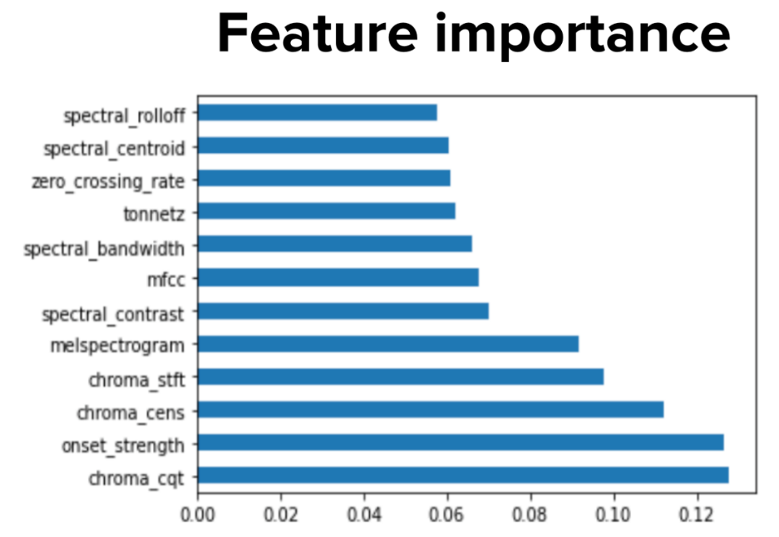

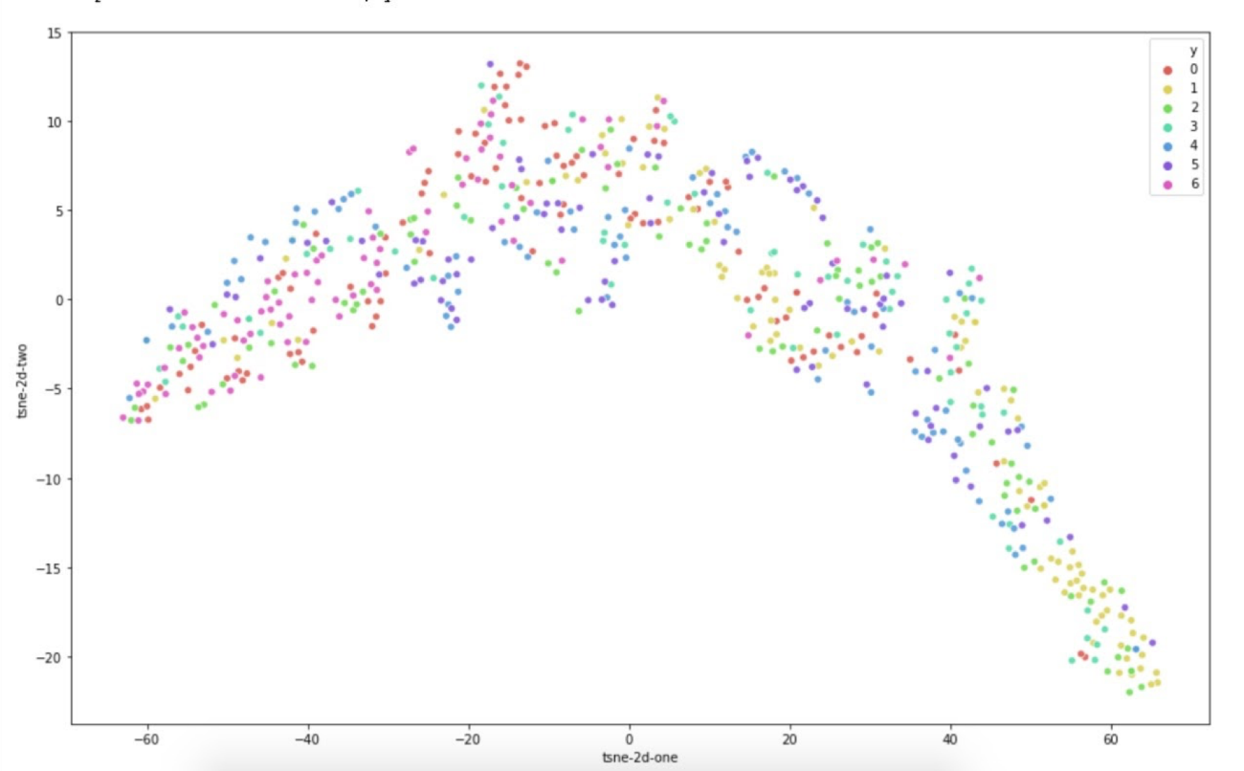

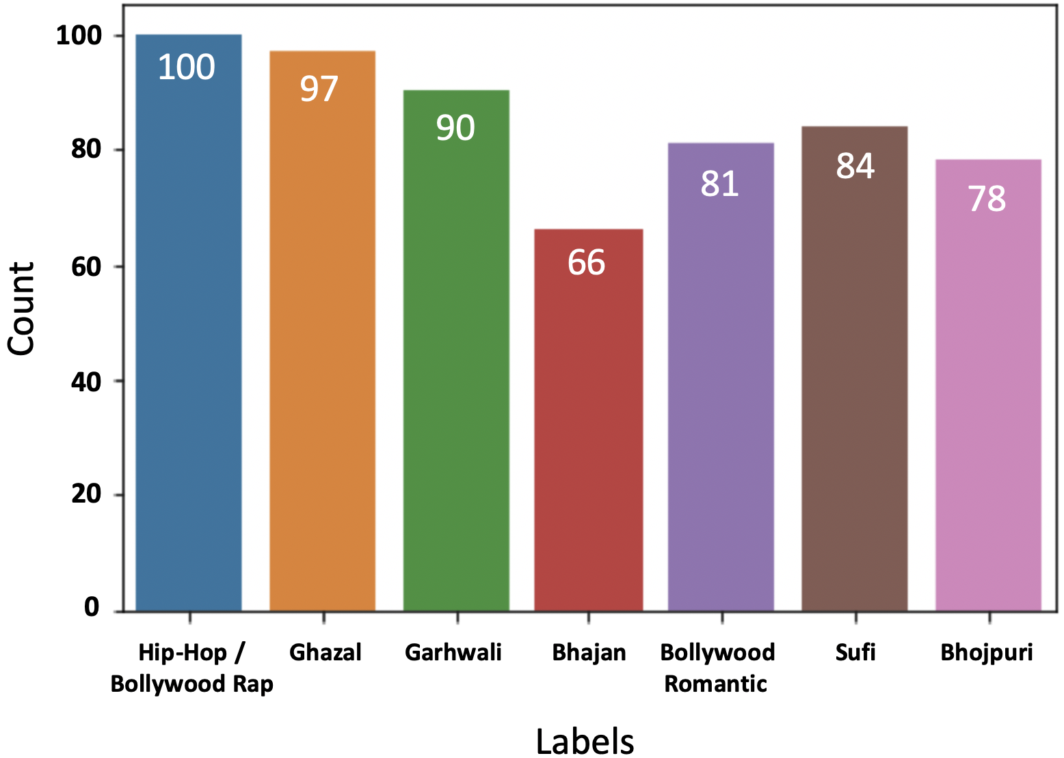

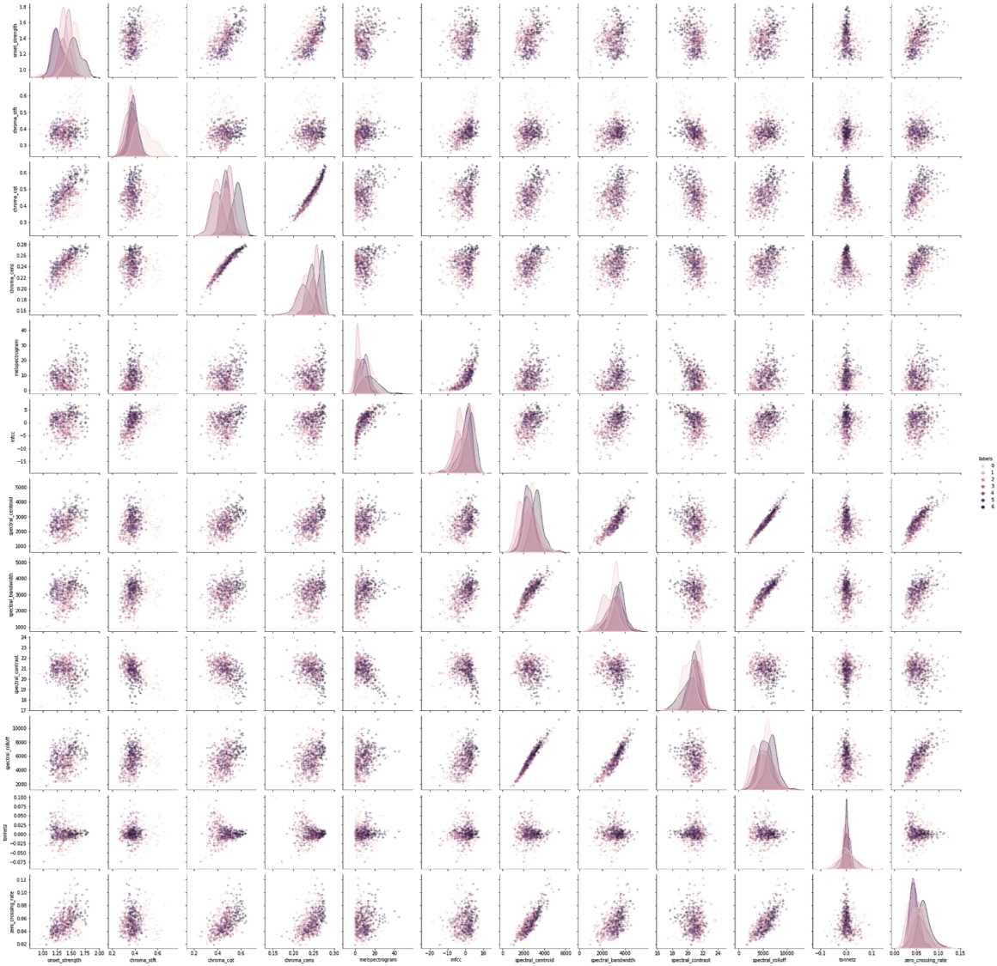





**IV. Machine learning models with hyper parameter tuning**

**1. k-Nearest Neighbors (kNN)**

**Hyperparameters to Tune:**

* **Number of Neighbors (k):** The count of nearest neighbors to consider. Typically, odd numbers are chosen to avoid ties.
* **Distance Metric:** Euclidean, Manhattan, or Minkowski distances are common choices.
* **Weights:** Uniform (all points in the neighborhood are weighted equally) or distance (closer neighbors have a greater influence).

**2. Support Vector Machine (SVM)**

**Hyperparameters to Tune:**

* **Kernel Type**: Choices include linear, polynomial, radial basis function (RBF), and sigmoid. The kernel defines the decision boundary's shape.
* **C (Regularization Parameter):** Balances the trade-off between achieving a low training error and a low testing error (generalization).
* **Gamma (for RBF Kernel):** Controls the influence of individual training examples; low values imply far and high values imply close influence.

**3. Decision Trees**

**Hyperparameters to Tune:**

* **Max Depth:** The maximum depth of the tree. Controls overfitting as higher depth can capture more information about the data.
* **Min Samples Split:** The minimum number of samples required to split an internal node.
* **Min Samples Leaf:** The minimum number of samples required to be at a leaf node. A smaller leaf makes the model more prone to capturing noise in train data.
* Hyperparameter Tuning Techniques
* **Grid Search:** Exhaustively searches through a manually specified subset of the hyperparameter space.
* **Random Search:** Randomly samples the search space and evaluates sets from a specified probability distribution.
* **Cross-Validation:** Use k-fold cross-validation to ensure that every observation from the original dataset has the chance of appearing in the training and test set.

1. **Gradient Boosting**

**Hyperparameters to Tune:**

* **Learning Rate**: Determines the impact of each tree on the final outcome. A lower rate requires more trees but can lead to better models.
* **N Estimators:** The number of trees to be used in the ensemble. Too many trees can lead to overfitting.
* **Max Depth**: Controls overfitting by limiting the depth of the trees. Deeper trees can capture more information about the data.
* **Min Samples Split & Min Samples Leaf**: Identical to the explanation provided, these control the minimum number of samples required at internal nodes and leaves, affecting overfitting and underfitting.

1. **Random Forest**

**Hyperparameters to Tune:**

* **N Estimators:** The number of trees in the forest. More trees can improve accuracy but increase computational complexity.
* **Max Features:** The number of features to consider when looking for the best split. Can affect the diversity of trees in the forest.
* **Max Depth, Min Samples Split & Min Samples Leaf**: As described, these parameters help control the complexity of the trees, affecting overfitting and model performance.

**V. Performance Evaluation**

* **Accuracy:** Overall correctness of the model on the test set.

Precision, Recall, F1 Score: Especially useful if the dataset is imbalanced.

* **Confusion Matrix:** Provides a detailed breakdown of correct and incorrect classifications for each class.
* **ROC-AUC Score:** The area under the receiver operating characteristic curve; useful for binary classification problems.

**Performance Evaluation Steps -**

* **Split the Data:** Divide your dataset into a training set and a test set (and optionally, a validation set).
* **Cross-Validation:** Implement cross-validation during hyperparameter tuning to validate the effectiveness of the model.
* **Evaluate Metrics:** Calculate the chosen metrics on the test set to gauge the model's performance.
* **Compare Models:** Compare the performance metrics of the kNN, SVM, and Decision Trees models to identify which model performs best for your specific genre classification task.
* **Interpret Results:** Discuss the results, highlighting the strengths and weaknesses of each model in the context of your dataset. Consider aspects like model complexity, interpretability, and computational efficiency.

**VI. Comparison of different techniques used**

|  |  |  |  |  |  |
| --- | --- | --- | --- | --- | --- |
| Technique | Algorithm | Accuracy | Robustness | Complexity | Scalability |
| SVM | Support vector machine | 62% | High | moderate | high |
| Gradient boosting | Ensemble (decision tree) | 74% | High | moderate | moderate |
| K – nearest neighbor | KNN | 60% | Moderate | Moderate | Low |
| Decision Trees | Decision Trees | 45% | low | Low | Low |
| Random forest | Random forest | 45% | low | Low | Low |

**Overall Comparison:**

Accuracy: Among the techniques evaluated, Gradient Boosting exhibited the highest accuracy of 74%, followed closely by SVM with an accuracy of 62%. kNN achieved an accuracy of X%.

* Robustness: While all techniques demonstrated robust performance, Gradient Boosting and SVM exhibited slightly higher stability across different folds of cross-validation compared to kNN.
* Complexity: SVM tends to be computationally intensive, especially with large datasets, due to its quadratic time complexity. Gradient Boosting, on the other hand, can be slower to train but offers high predictive performance. kNN has lower computational complexity during training but may suffer from higher inference time with large datasets due to its instance-based nature.
* Scalability: Gradient Boosting and SVM may scale well with increasing dataset sizes when optimized and parallelized effectively. kNN's performance may degrade with larger datasets due to its reliance on distance calculations for prediction.

**VII. Learning beyond classroom**

**Library imported :** Sklearn, NumPy, pandas, Librosa, Plotly, SciPy, Seaborn, Matplotlib

In our pursuit of developing a song genre identification and classification project, we've extensively explored techniques and tools beyond the traditional classroom setting. The following are key aspects we've learned outside the classroom:

* Preprocessing Audio using Librosa Library:

Utilized Librosa, a Python library, for audio preprocessing tasks including loading audio files, resampling, and feature extraction (e.g., MFCCs, chroma features).

* Plotting Visualization:

Employed Matplotlib and Seaborn libraries to visualize audio data distributions, aiding in understanding feature characteristics and patterns.

* Understanding Song Preprocessing from Literature/Research Paper:

Extracted insights from literature and research papers regarding advanced preprocessing techniques tailored for audio data.

* Implementation of PCA (Principal Component Analysis):

Implemented PCA to reduce the dimensionality of audio features, mitigating the curse of dimensionality and improving model performance.

* Training Audio Models with Machine Learning Algorithms:

Explored various machine learning algorithms such as KNN, GMM, and SVC for training audio classification models, understanding their strengths and suitability for the task.

* 3D Plots using Plotly:

Utilized Plotly, a Python library, for creating interactive 3D plots, facilitating visualization of multidimensional data and enhancing analysis capabilities.

* By delving into these aspects outside the classroom, we've acquired practical skills and knowledge crucial for the successful development of our project on song genre identification and classification.

**VIII. Learnings and challenges you faced while doing the Project**

In the course of undertaking this project, we encountered a myriad of learnings and challenges, ranging from data collection to model training. Below, we outline our experiences:

**Learnings:**

* Data Collection Challenges: Obtained firsthand experience in the complexities associated with data collection. Sourcing a diverse and comprehensive dataset posed significant challenges due to the need for representative samples across various genres.
* Data Filtering: Learned the importance of meticulous data filtering to ensure the quality and relevance of the dataset. This process involved removing irrelevant or noisy samples and addressing issues such as mislabeled data.
* Data Preprocessing: Explored various techniques for data preprocessing, particularly in the context of audio data. Tasks included standardization, feature extraction, and handling missing or inconsistent data.
* Model Training: Gained valuable insights into the intricacies of training machine learning models with large datasets. Optimizing model performance while managing computational resources and memory constraints became a focal point of our learning.

**Challenges Faced:**

* Data Collection: The primary challenge revolved around acquiring a sufficiently large and diverse dataset encompassing multiple music genres. Limited availability and access to labeled data posed a significant hurdle.
* Data Filtering: Ensuring data quality and relevance necessitated meticulous filtering processes, consuming considerable time and effort. Addressing issues such as class imbalances and label inconsistencies added complexity to this task.
* Data Preprocessing: Preprocessing audio data presented unique challenges, including handling various audio formats, standardizing sampling rates, and extracting meaningful features while preserving relevant information.
* Model Training with Large Datasets: Training machine learning models with a dataset of substantial size (4 GB) posed computational and resource challenges. Optimizing model training pipelines and leveraging techniques for memory management became imperative.

Navigating these challenges provided invaluable learning opportunities, reinforcing the importance of adaptability, resourcefulness, and perseverance in the face of complex real-world data science projects. Through iterative problem-solving and collaboration, we successfully addressed these challenges, ultimately advancing our project towards its goals.

**IX. Conclusion**

**Achieved Project Goals:**

Successfully developed a tool for classifying Indian songs into genres.

Utilized kNN, SVM, and Decision Trees, gradient boosting, random forest optimized via hyperparameter tuning.

**Algorithm Insights:**

**kNN:** Good for nuanced similarities, but slower with large datasets.

**SVM:** Best performance in high-dimensional data; computationally intensive.

**Decision Trees:** Highly interpretable; requires careful tuning to avoid overfitting

**Gradient Boosting:** Excelling in accuracy and adaptability for diverse data types; can be prone to overfitting without careful parameter tuning.

**Random Forest:** Offers robustness and ease of use, performing well across a broad range of data; however, it can be less interpretable due to its ensemble nature..

**Performance Evaluation:**

Comprehensive evaluation using accuracy, precision, recall, F1 score, ROC-AUC.

**Gradient Boosting** showed the highest accuracy among the algorithms.

**Challenges and Learnings:**

Complexity of Indian music genres posed significant challenges.

Highlighted the importance of robust feature extraction and model selection.

**Future Directions:**

Explore deep learning models for improved classification.

Create more extensive datasets for a broader genre spectrum.

Potential integration with music streaming services for enhanced recommendations.

**Final Thoughts:**

Project marks a significant advancement in automated Indian music classification.

Opens new avenues for cultural appreciation and innovation in music technology.